**SMART IRRIGATION SYSTEM BASED ON IOT**

**ABSTRACT**

Automation of farm activities can transform agricultural domain from being manual and static to intelligent and dynamic leading to higher production with less human supervision. This project proposes an automated irrigation system which monitors and maintains the desired soil moisture, required level warnings of temperature and humidity. When conditions are too humid, it may promote the growth of mold and bacteria that cause plants to die. So humidity is given to them as a warning measure above a minimal level.The setup uses soil moisture sensors which measure the exact moisture level in soil. Temperature and weather conditions are provided so that they have prior knowledge. IOT is used to keep the farmers updated about the status of sprinklers. This information is given to them by open weather app which is interfaced with this project.

**INTRODUCTION**

Now that we can connect everyday objects—kitchen appliances, cars, thermostats, baby monitors—to the internet via embedded devices, seamless communication is possible between people, processes, and things.By means of low-cost computing, the cloud, big data, analytics, and mobile technologies, physical things can share and collect data with minimal human intervention. In this hyperconnected world, digital systems can record, monitor, and adjust each interaction between connected things. The physical world meets the digital world—and they cooperate.

An automated smart irrigation system for efficient growth of crops and prior detection of weather conditions using mobile app has been proposed. Soil Parameters like soil moisture, humidity, weather conditions like temperature are been measured.

**LITERATURE SURVEY**

EXISTING SCENARIO**:**

The scenario of decreasing water tables, drying up of rivers and tanks, unpredictable environment present an urgent need of proper utilization of water, soil fertility and maintaining humidity conditions. To cope up with this use of temperature and moisture sensors at suitable locations for monitoring of crops is implemented. An algorithm developed with threshold values of temperature and soil moisture can be programmed into micro controller based gateway to control water quantity. The technological development in open source software and hardware make it easy to develop the device which can make better monitoring and wireless sensor network.

PROPOSED SYSTEM OVERVIEW:

In the proposed system collecting all the data from various sensor like temperature, humidity, moisture and other environmental factors from the open weather app. During analysis the data gathered from the various sensor then those data is used to all the volunteer for further use. System is build through IOT platform. The system will contain many module at various geographical position and all these modules will send the data to this platform, ,which will give some idea to focus on the environmental factor, which are good for the farm.

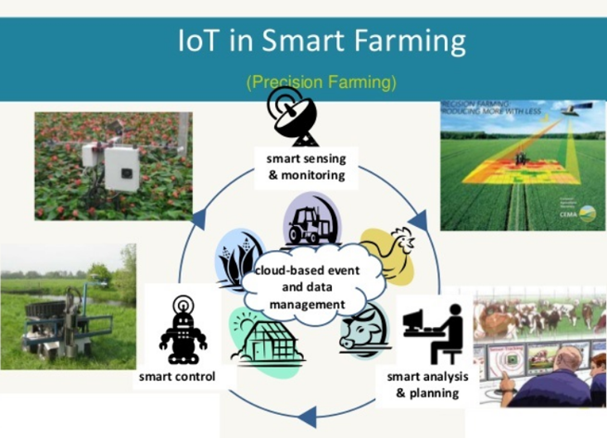

**BLOCK DIAGRAM**

Using various resources like IOT Watson platform, node-red application, Open weather app, Python IDLE , IOT sensor simulator.

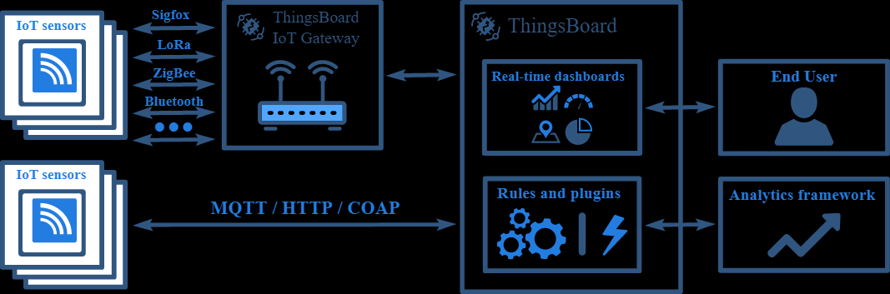

**NODE-RED FLOW CHART AND SOFTWARE DESIGNING**

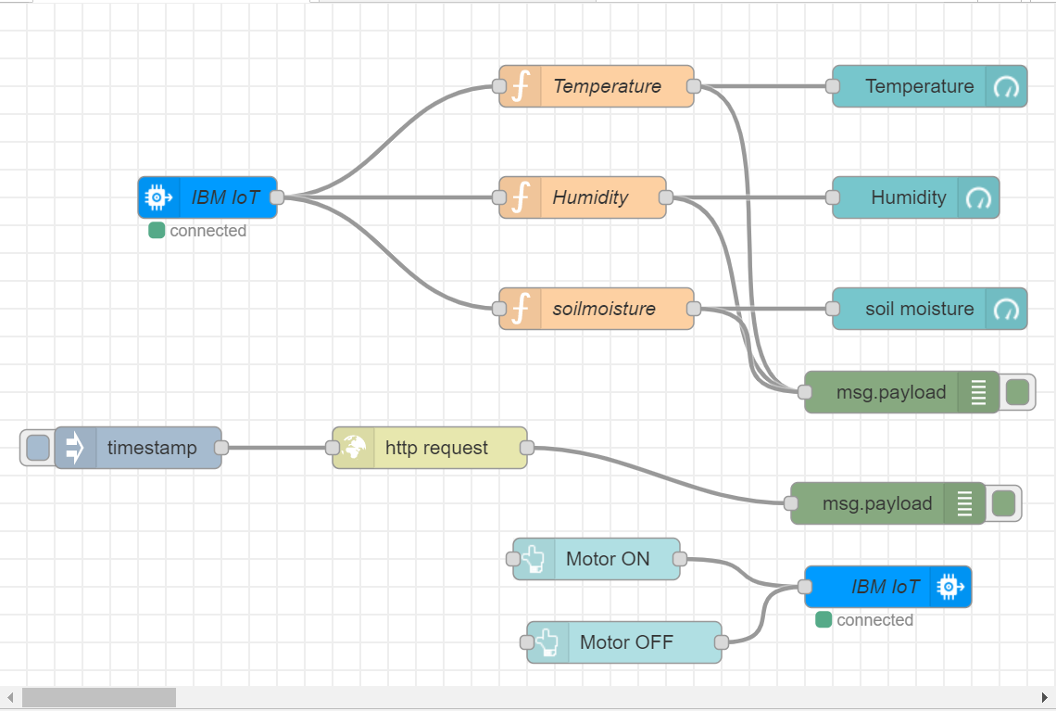

**RESULT:**

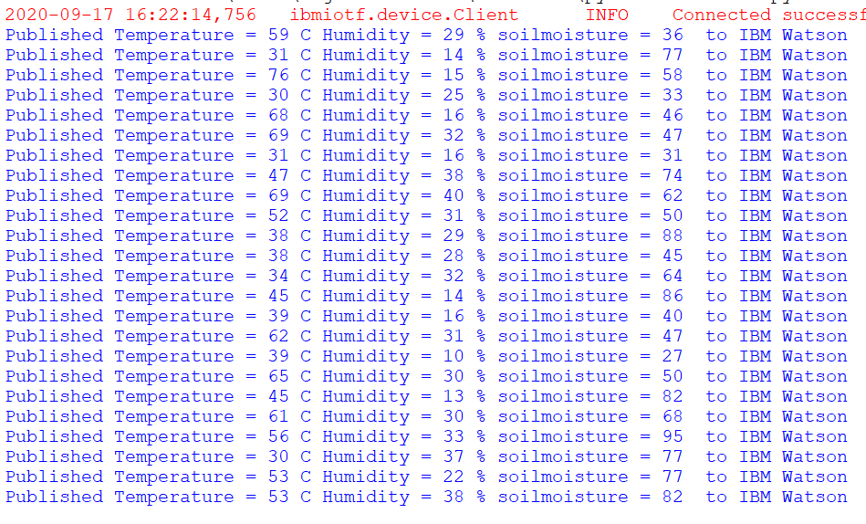

The values are continuously sensed by the sensor and information is been provided to the farmer from the UI interface and app.

**Smart irrigation system advantages**

* Irrigating via smart system is more effective and efficient compare with the traditional ones. This system automatically will recognize, irrigate and dung any area that needs water and humidity.
* This system will be installed under the ground.
* Since this system will be installed under the ground so there are no unsightly hoses stretched across the land. Sprinkler heads up in case of water need and then set beck when irrigating is done.
* Smart irrigation system works as a drip system. It has a soil moisture sensor and is a good replacement for traditional watering methods. It is the best solution to reduce water waste.
* Smart irrigation system knows when to start the watering, how long it will take and when finish its job. It even knows what days should do watering. It proves the use of water can be diminished.
* This system will consider the soil humidity and will stop the next watering schedule if it rains. You can control the position by your smart phone or computer from outside.
* It provides temperature and weather forecast of over 10 days which help farmers on idea of growth and implantation of new crops.

**Smart irrigation system disadvantages**

* Smart watering system is a bit expensive. And if it damages,the cost re-construction is still higher.
* Depending on the size of your property, you will need more systems.
* If you want to use this system for lawn watering, it’s better to fix it under the ground before planting. Because some parts of the lawn will be harm because of holing.
* Even the most effective systems have their pitfalls. Wind can bring havoc on sensors and thereby damaging it.
* Underground pests can damage the water delivery system resulting in water pooling or broken parts.

**APPLICATIONS**

* IoT in agriculture uses mobile apps, robots, drones, remote sensors and computer imaging combined with continuously progressing machine learning and analytical tools.
* It is used for monitoring crops, surveying and mapping the fields and provide data to farmers for rational farm management plans to save both time and money.
* It is also used in smart home and lawns, smart gardening purpose, smart city projects, smart farming in agriculture.

**CONCLUSIONS**

The farm owner can monitor the process online through a UI app. Through this project it can be concluded that there can be considerable development in farming with the use of IOT and automation. The warning system can be given to farmers for the temperature rises and intense weather conditions. The system uses information from soil moisture sensors to irrigate soil which helps to prevent over irrigation or under irrigation of soil thereby avoiding crop damage.

**FUTURE SCOPE**

To improve the efficiency and effectiveness of the system, the following recommendations can be put into consideration. The project can be used as a base for realizing a scheme to be implemented in other projects of greater level such as weather forecasting, temperature updates, device synchronization etc. Option of controlling the water pump can be given to the farmer i.e. he can switch on/off the pump in order to start/stop the process of irrigation without being present at the farm. The idea of using IOT for irrigation can be extended further to other activities in farming such as cattle management, fire detection and climate control. This would minimalize human intervention in farming activities.

**APPENDIX**

SOURCE CODE:

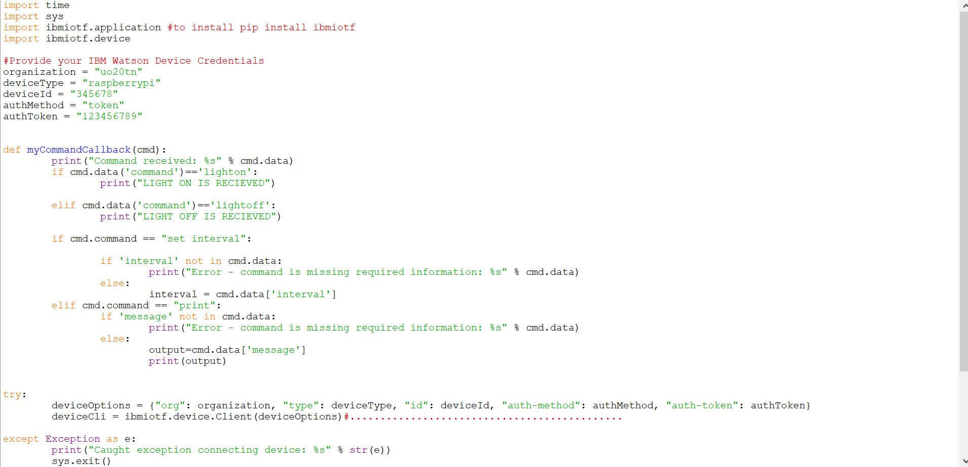

UI OUTPUT:

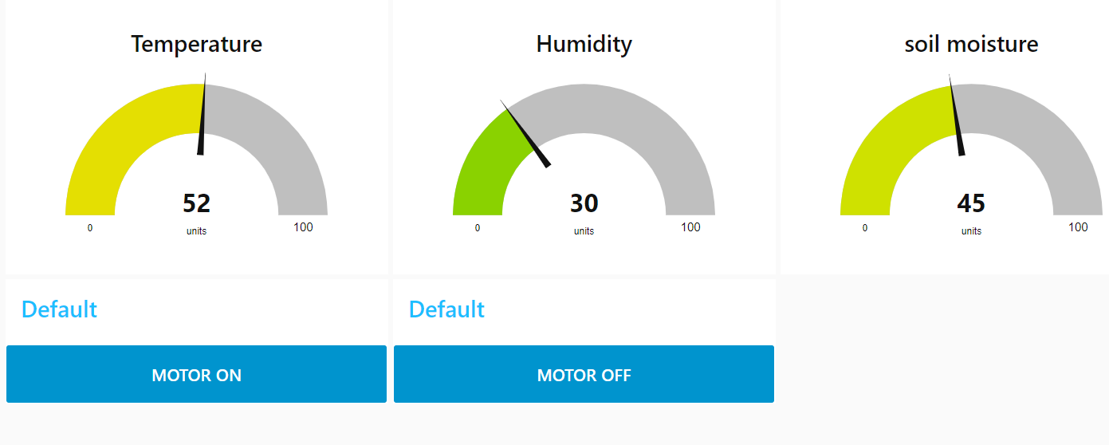

**BIBILIOGRAPHY**

Smartbridge videos, Smart-internz, Node-red application,Python IDLE,IBM cloud,Open weather,Fast2sms,Notepad,IBM IOT Watson platform.

**ACKNOWLEDGEMENT**

I would like to thank my video instructor Sandeep sir and my mentor ancy ma’am who supported me through the different phases of the project. Also, I am grateful to smartbridge for providing me the resources which led to learning and complete my project.

**REPORT BY:**

Sai Nagendra

Ganesh Sakhe

Shivank M

Aman Raj